Inclusive and Credible Elections for Sustainable Peace:

UNDP/GPECS Approach to Electoral Assistance in Post-conflict Countries

Choosing one’s political representation or running for a political office are fundamental human rights and give citizens the opportunity to voice their interests and preferences. For the credibility of elections or referenda, and ultimately for the acceptance of results, it is of utmost importance that all societal groups are included and have equal access to the electoral process. In peace processes and transitional contexts, elections are a central element and widely considered to be the main method of achieving a non-violent resolution to political controversies. Though, during the electoral cycle, social and political differences are played out and existing fault lines in society are often exacerbated , hence the risk for violence increases during these periods. Even in rather peaceful environments and established democracies, elections provide entry points to disputes and can potentially lead to violent conflict. Electoral assistance in volatile and/or post-conflict countries therefore requires a special approach in order to create an inclusive environment, based on institutionalized dialogues, responsive institutions and respect for democratic processes. Electoral assistance can therefore be a key mechanism to enable conflict prevention.
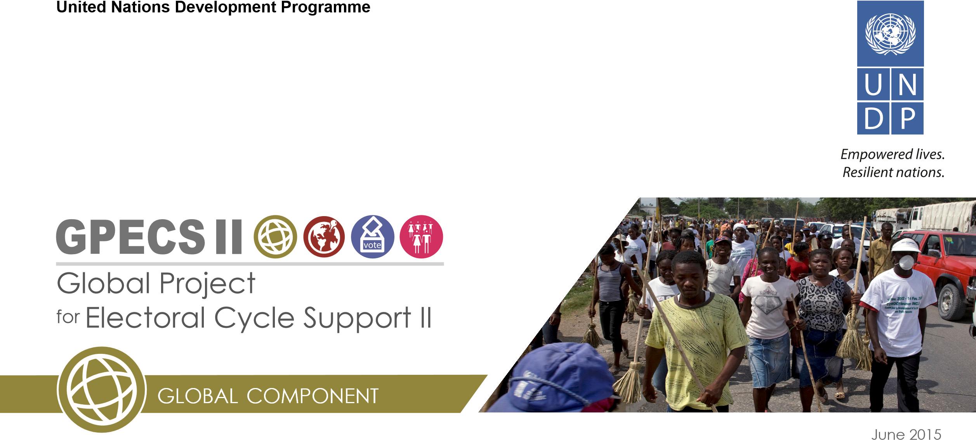
The Global Project for Electoral Cycle Support (GPECS Phase II 2015 - 2017) is UNDP’s main tool to deliver electoral policy and programme support on national, regional and global level. Under the global component, together with the Department of Political Affairs’ Electoral Assistance Division (EAD) and other relevant UN entities, such as UN Women, and the Department of Peacekeeping Operations, GPECS develops policies regarding the prevention of electoral violence and the creation of safe and secure environments during elections. Furthermore, GPECS develops training courses and knowledge tools on prevention of and response to electoral violence in areas such as security planning for elections, gender based violence in electoral and political processes, electoral dispute resolution and others. In order to promote, share and use the established lessons learned and best practices, GPECS engages with global partners and networks.
Electoral Audit Afghanistan An unprecedented effort was made by the international community, led by the UN Assistance Mission in Afghanistan (UNAMA), with the direct support of UNDP, in regard to the presidential polls of UNDP. Following the second round of elections and the subsequent allegations of fraud from both sides, an audit process of all ballots from the presidential run-off was conducted in June 2014. In order to prevent widespread political unrest and violence, complex and massive endeavors were delivered by UNAMA and UNDP. Efforts included the mobilization and deployment of over 125 UN auditors to Kabul in less than 15 days, as well as the setting up of an entire operational system to assist the Independent Election Commission in auditing approximately 23,000 ballot boxes in a fluid and highly tense political environment. This audit, which was supported by GPECS through technical and policy advice, was unique in terms of mobilization and outreach. The audit and the subsequent agreement on a national unity government, led to a political solution and prevented post-electoral conflict. The lessons-learned from this intervention will have global relevance for future electoral disputes.
Institutional and Context Analysis as well as Risk Assessments are key to the design and the implementation of electoral assistance programmes, which work throughout the entire electoral cycle: from supporting the development of electoral legislation to promoting civic education, supporting the inclusive registration of voters, etc. A thorough understanding of the context, the stakeholders and their interests is the basis for preventing or mitigating electionrelated violence. Therefore, UNDP electoral assistance is based on the political assessment conducted during the obligatory Needs Assessment Missions (NAM)³ led by EAD. Key issues during the NAM are the potential for electoral violence, as well as the EMB’s capacities for the inclusion of women, youth and minorities. Based on the recommendations of the NAM report, an electoral assistance programme is developed by UNDP. While conflict sensitivity and do-no-harm are integral parts of all project’s design and implementation, in countries with an increased potential for (post-) electoral violence, additional thorough risk assessments are conducted.
Risk assessments highlight likely triggers for unrest and violence (such as a (potential) delay in the announcement of results, non-acceptance of results, lack of access of certain groups of the population, etc.), as well as potential regional hotspots. Based on the assessment, measures to mitigate the identified risks can be developed and implemented. Such measures can include (among others):
- Facilitation of political dialogues;
- Facilitation of political party accords (in regard to acceptance of results, non-violence, appropriate use of media, etc.);
- Training of security forces;
- Support to the judiciary, e.g. to electoral dispute resolution bodies and to electoral complaint mechanisms.
Strengthening the capacities of Electoral Management
Bodies and other relevant stakeholders is at the core of UNDP’s Electoral Assistance on the national level and a

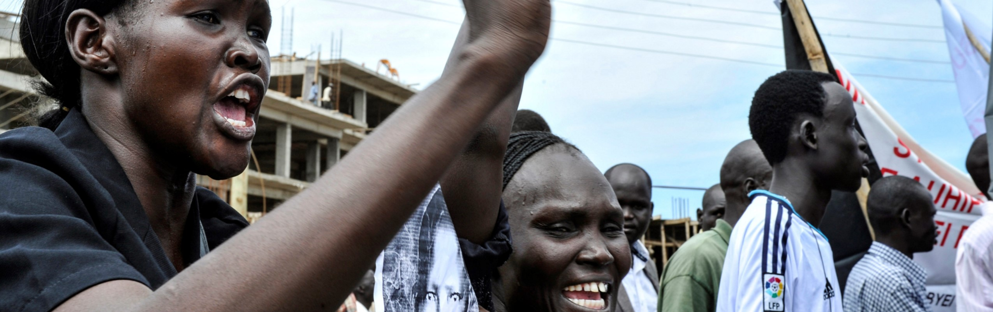
main contribution to the facilitation of inclusive and credible elections, contributing to the prevention of potential conflicts. The EMBs, as the responsible body for the conduction of inclusive elections are supported by UNDP⁴ in the field of civic and voter education, outreach to CSOs, women and youth groups, as well as media and communication. Key to inclusion is also the engagement with Political Parties, which is regarded as the main entry point to prevent violence and ensure the inclusion of women, youth and minorities. GPECS also support direct interventions at the country level through the GPECS Country Window, which provides targeted emergency support to individual national-level projects that require it, especially to countries in post-conflict or transition contexts. In addition, GPECS’s Quick Intervention Fund for Women’s Participation in Post-Conflict Settings and Countries in Transition (QIF) allows for quick action in regard to identifying, designing and implementing measures to advance women’s participation and supporting initiatives to prevent gender based violence around electoral and political processes.
GPECS Regional Approach to the prevention of electoral violence: in the Asia-Pacific Region, UNDP has established itself as the lead organization working on developing an understanding of the triggers for, and actors involved in, electoral violence alongside identifying the most effective programmatic interventions for mitigating the risk of electoral violence. UNDP is the only organization in the region to have published case studies for seven countries in South and South-East Asia and distilled regional lessons that have been fed back into national EMB strategic planning and programming. UNDP’s research has illustrated the most important triggers of electoral violence in South and South East Asia. Generally these triggers revolve around real and perceived fraud; corruption; clientelism; patronage; patriarchy; a belief that politics is merely a mechanism for solidifying business interests; and ethnic, religious and socioeconomic conflicts and grievances.

- In some cases, Needs Assessment can be done through in country missions or desk reviews.
- UNDP support to EMBs includes operational, logistical, financial and other aspects, the areas mentioned above are solely the ones which target the inclusion of women, youth and other marginalized groups.

For more information, contact Aleida Ferreyra at aleida.ferreyra@undp.org

Article 25, International Covenant on Civil and Political Rights.
ZIF Report.

